**ASCENDING ORDER**

**EXP NO: 9**

**AIM:**To arrange the numbers in ascending order using 8085 processor.

**ALGORITHM:**

1. Initialize HL pair as memory pointer.
2. Get the count at 4200 into C – register.
3. Copy it in D – register (for bubble sort (N-1) times required).
4. Get the first value in Accumulator.
5. Compare it with the value at next location.
6. If they are out of order, exchange the contents of Accumulator and Memory.
7. Decrement D –register content by 1.
8. Repeat steps 5 and 7 till the value in D- register become zero.
9. Decrement contents of C –register by 1.
10. Repeat steps 3 to 9 till the value in C – register becomes zero.

PROGRAM:

LXI H,5000 ;Set pointer for array

MOV C,M ;Load the Count

DCR C ;Decrement Count

REPEAT: MOV D,C

LXI H,5001

LOOP: MOV A,M ;copy content of memory location to Accumulator

INX H

CMP M

JC SKIP ;jump to skip if carry generated

MOV B,M ;copy content of memory location to B - Register

MOV M,A ;copy content of Accumulator to memory location

DCX H ;Decrement content of HL pair of registers

MOV M,B ;copy content of B - Register to memory location

INX H ;Increment content of HL pair of registers

SKIP: DCR D ;Decrement content of Register - D

JNZ LOOP ;jump to loop if not equal to zero

DCR C

JNZ REPEAT ;jump to repeat if not equal to zero

HLT

INPUT:

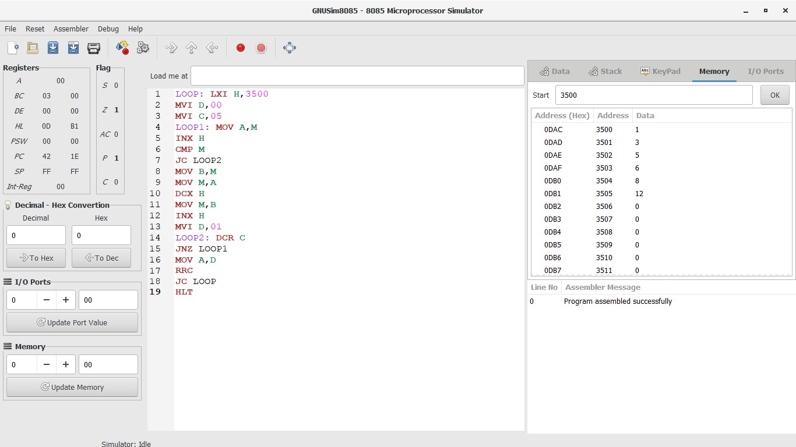

OUTPUT:



RESULT:

Thus the program was executed successfully using 8085 processor simulator.